The Frog Lives by the Pond

Tune: Farmer in the Dell

The frog lives by the pond

His tongue is oh so long

It reaches high to catch a fly

And then he sings this song

Ribbit ribbit ribbit,

Ribbit ribbit ribbit,

He hops around making a splashing sound,

The frog lives by the pond.

Five Green and Speckled Frogs

Five green and speckled frogs,

Sitting on a speckled log,

Eating the most delicious bugs,

Yum! Yum!

One Jumped into the pool,

Where it was nice and cool,

Now there are 4 green speckled frogs.

*(Count down until none)*

FIVE LITTLE FROGS

Tune: Five Little Ducks

One little frog was balancing  
On a lily pad of green.  
He thought that it was so much fun,  
He called for another little frog to come.

*(Count up to five frogs then say)*

Five little frogs were balancing  
On a lily pad of green.  
They thought that it was so much fun Until they sank into the mud!  
Glub, glub, glub!

**[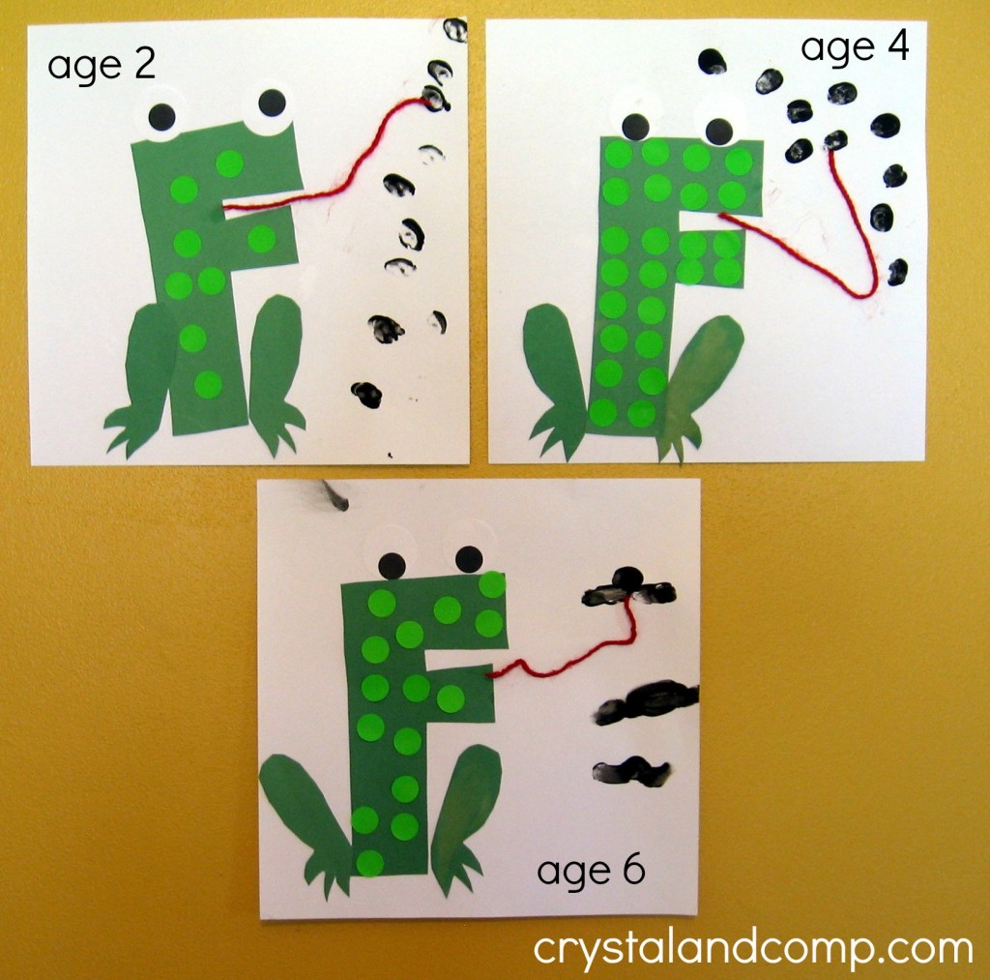](http://www.crystalandcomp.com/wp-content/uploads/2013/05/F-is-for-frog-2-crystalandcomp.jpg)**