Thank you for deciding to be a coach! We could not do this without you. What is a Coach and how do you get things done? Glad you asked!

**What is a Coach?**

A coach is the person responsible for getting the cash donations to our MLS representative so the Heart Reps can have an easy pick up. They are also responsible for creating and managing their team. This includes creating a team name and putting it online, signing up their team members online, and giving their team important information.

**Who can walk?**

If you know someone that wants to participate in the walk, they can! You just need to sign them up on your team. There are no fees.

**Are there T-shirts?**

In order to receive a T-shirt an individual needs to raise $100 in donations.

**What about Cash Donations?**

If you receive Cash donations, we will need you to fill out a chart (Included). It includes things like name of the person donating, the date you received the donation, and the amount. You will need to send this with the cash via interoffice mail to Carissa Owens at NW. If you want to create a fundraiser for your team, you certainly can. You cannot ask members for donations. It has to be staff, friends, and family.

**How to Fill Out the Chart?**

It's pretty self-explanatory. We included some examples in there. Where it says transaction category, put donation, registration, or walker. Donations are for the cash being sent through the interoffice mail. Registration is for anyone you sign up to your team. Some people may not be walking, but wanted to be added so they can help earn donations. This is completely fine. Just make sure to put Walker for the people that will actually be participating in the event. The Total from Participant is just the total within that envelope towards that one person. If it is a team donation- just write Team.

**Online Donations?**

Once you have created your team and added at least one member, online donations become available. You can post links onto your social media and get your friends/family to donate under your name. There is a separate link for each individual person. Why is this part important? To get a T-shirt, an individual needs to raise $100 in donations. This helps keep track who has gotten the $100.

**How do you Create and Track your Team Online?**

You will need to go to the home website here:

<http://www2.heart.org/site/TR/HeartWalk/SWA-SouthWestAffiliate?pg=entry&fr_id=2181>

1. You will scroll down until you see View All Companies.  
   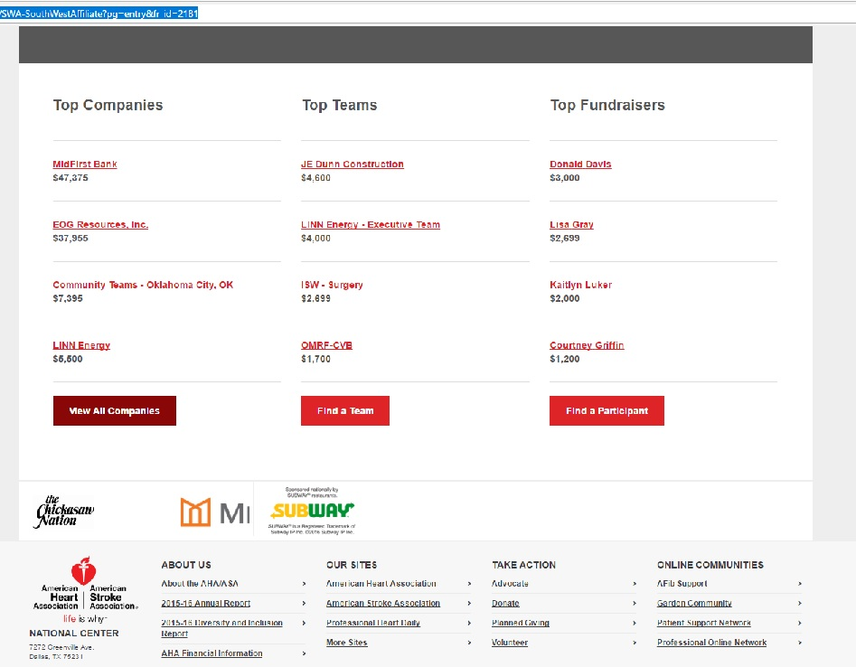
2. Then you will need to find Metropolitan Library System and click on it.  
   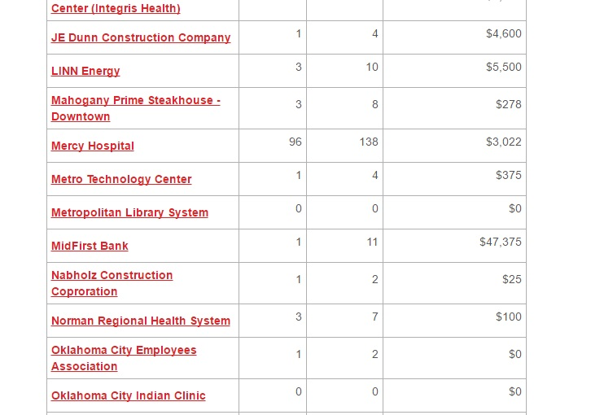
3. Click on Create a Team. It’ll be on the left.  
   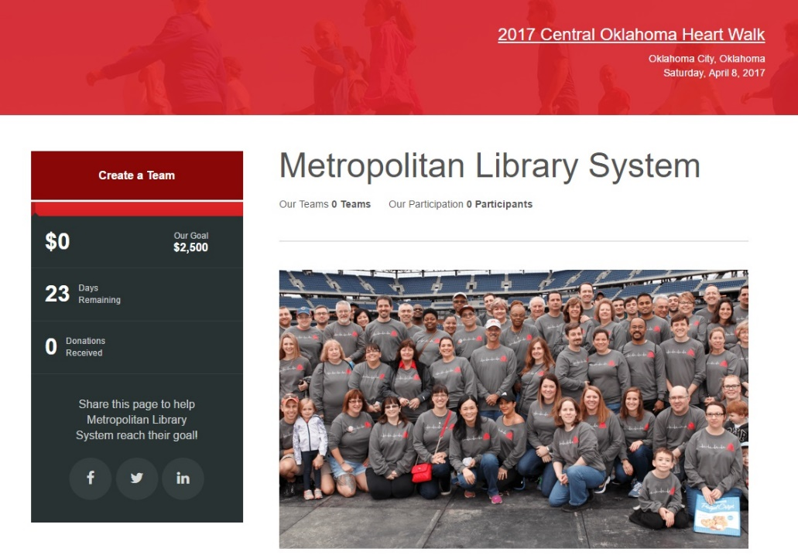
4. You will need to click Join as New Participant. (After you create your team and user, you can just login instead to manage it.)
5. Fill in all the information as you go through. Leave the team company as Metropolitan Library System. When you leave the team company, it’ll waive the fees. Finish filling in the information.
6. Congratulations! You have created your team and signed yourself up.

To sign up your team mates, use the link for your team. When they click on the link, there will be an option to Join the Team or to Donate. Have them Join the Team. It will skip the choosing a team step. Have them fill out their information. It'll have them create their own specific login and password. They will not have access to editing the Team site. The first person to create/join the team is in charge of the site. Now you can use the links to get your online donations. Yay!

**Managing your Site/Team**

This part is pretty fantastic. You will get 2 links. One is for your individual site and one is for the Team. You can edit the end of the link to reflect that. You can change the photos, videos, and stories for both. It will also automatically track all the online donations that come through from your link. You can even set up a message on your team page so only your team members see it. It is highly customizable and very user friendly. There's even a live chat option on the right hand side in case you have questions. You can make these pages reflect you and your team. Show off your personality.

**Other information you can give your team:**

* Staff Association will have some door prizes for the people that show up early to the walk.
* They have not finalized the walking route yet because of construction. It will be 5K though.
* Would any of your team mates be willing to wear the Spoticus costume?

If you have any further questions, feel free to e-mail me at [Carissa.owens@metrolibrary.org](mailto:Carissa.owens@metrolibrary.org) or you can also ask Drea Gates at [drea.gates@metrolibrary.org](mailto:drea.gates@metrolibrary.org)

Again, thank you so much for doing this. Don’t forget to have fun.