In-Library Engagement Committee Meeting
November 6, 2024

Discussion
- Bre has prior commitments, so she is unable to be on the committee this year.
- Talked about the Sharepoint Site and the resources located there. Encouraged everyone to take a look and put ideas into the “Inspiration Places” document.
- Talked about deadlines; decided on an early January due date for all toolkits and documents. January 10th, 2025 tentative due date.
- Kristin suggested looking at the CSLP Reads shop, which has a lot of items, but to be aware that it takes a very long time to ship.
Décor Ideas
- Rainbow film for windows
- Window chalk
- Shelfie Backdrop
- Color filter pictures in Canva
Display Ideas
- Nutrition Display with lots of colorful foods (Natural Grocers will come and give a class for free in reference to nutrition)
- Different color displays (each display has a different book cover color, change weekly)
- Art Displays (different art styles each week)
- Marketing may be doing bookmarks with Spoticus in different art styles
Passive Program Ideas
- Giant coloring sheets (either large printables or smaller sheets taped together)
- Scratch-off Tickets (Book recommendations underneath?)
- Scavenger Hunts
- Paint by sticker
- Paint by number
- Coloring pages
  - From CSLP and others
  - Can do pencil pictures of the libraries to color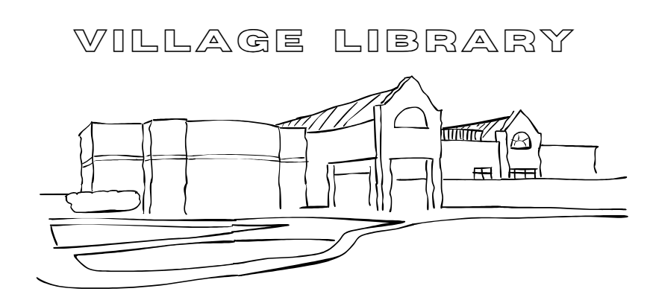
Take-Home Kit Ideas
- Spice kits with different color spices
- Painting kit
- Fridge magnets
- Art using watercolor and crumpled paper
- Health and Wellness – water bottle and stickers take home kit
In Person Program Ideas
- Woodburning Art using watercolor (some libraries already have wood burning kits)
- Book Making/Paper making
- Colorful Emotions story time
- Whimsical Wonderful Art – teaching different art styles
- Book Hat – craft a book-themed hat
- Puzzle Contests utilizing colorful puzzles

