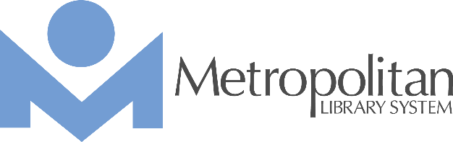

METROPOLITAN LIBRARY SYSTEM / OKLAHOMA COUNTY

300 Park Avenue, Oklahoma City, OK 73102 / www.metrolibrary.org

FOR IMMEDIATE RELEASE

CONTACT:
Kim Terry, Public Relations Manager
405.503.9220 c
kterry@metrolibrary.org

Metropolitan Libraries Open
June 1 for Phase 2

OKLAHOMA CITY, OK – The Metropolitan Library System announced that all libraries will be open for Phase 2 on Monday, June 1 2020.

Phase 2 allows a limited amount of customers in the building to use computers in one-hour sessions. The computers available will be spaced out for social distancing. Customers may also come to the building for copies or faxing.

Face masks are recommended for customers entering the building.

“We’re excited to see more of our customers,” Chris Kennedy, Metropolitan Library System Deputy Director of Library Services. “Curbside pick-up is going great, but we’ve definitely missed seeing some of our regulars who use the computers.”

Each computer use will be limited to a one-hour session. After each customer, library staff will disinfect the computer and the computer area for the next customer. Customers may sign up for another one-hour session, if computers are available.

“While customers will be allowed in the building for computer use, browsing of the physical collection is still not permitted at this time,” said Julie Ballou, Executive Director of MLS. “Customers have been asking for computer services including printing and copying, and we’re happy to be able to offer this to them during Phase 2.”

Customer holds will still be available through curbside pick-up, and books and other materials must still be returned to the outdoor bookdrops. “All books from the outdoor bookdrops will be couriered to a holding area where they will wait for 72 hours before added back to the collection,” Ballou said.

Holds can be placed online or by calling (405) 231-8650. Bonus book bags are also available for children. “If your children are running out of something to read or watch, just call us with a one-word theme for books, DVDs, CDs or audiobooks that your child would like,” Kennedy said. “Our skilled librarians will pick out five books, DVDs or other materials, that your kids will love.”

The bonus book bags must be picked up through curbside pick-up along with any other holds.

Online programs and events are another service that is still provided during Phase 2. “We’ve had a great reaction to some of our online storytimes,” Kennedy said. “Our ‘virtual’ Children Reading to Dogs events are so popular, we’ve begun offer more times for these.”

Other online services available are genealogy help one-on-one, Hoopla and Kanopy streaming movies and tv shows, job and career help through our online service, JobNow, and more.

Library hours remain the same, but hours for public computer use in Phase 2 are Monday – Thursday 9:00 a.m.- 8 p.m., Friday 9:00 a.m.- 5 p.m., Saturday 9:00 a.m. – 4 p.m., Sunday 1:00 p.m. – 5 p.m. For more information, contact our ask a librarian service at (405) 231-8650 or askalibrarian@metrolibrary.org.

###

About the Metropolitan Library System
The Metropolitan Library System is a public library system serving Oklahoma County residents. MLS includes 19 library branch locations. The Metropolitan Library System is the largest library system in Oklahoma, serving anyone who lives, attends school, or owns property in Oklahoma County. MLS circulates over 6 million materials each year.

