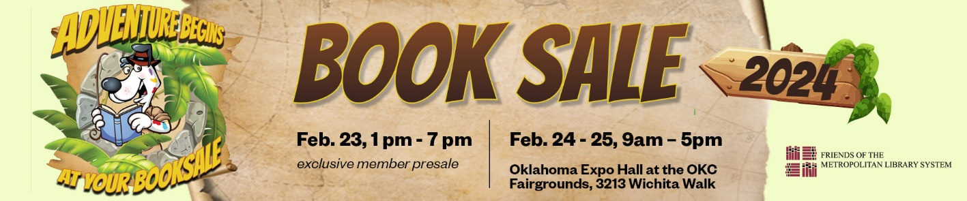

**Friends of the Library Booksale 2024**

Thank you for your part in raising awareness about the Friends of the Metropolitan Library System Booksale to be held Saturday, February 24 and Sunday, February 25 from 9:00am to 5:00pm at the OKC Fairgrounds in the Oklahoma Expo Building. The Booksale will traditionally go on regardless of the weather. It will not close unless the Fairgrounds does! Please check the event website [www.supportmls.org/fol/booksale](http://www.supportmls.org/fol/booksale) for the latest updates.

**MEMBERSHIP (NEW/CHANGE)**

**Members of the Friends of the Library can pre-shop 1pm to 7pm on Friday February 23!**

Memberships can be purchased online at [Supportmls.org/fol/membership](http://www.supportmls.org/fol/membership) until end of day, February 21. Memberships purchased on or before January 31, 2024 will be mailed tickets in an envelope.

Members who join between January 31 and February 21 must visit the will-call table at the Fairgrounds on Friday from 12pm to 6pm to pick up their tickets. If a membership was purchased and tickets were not received, they will be at the will-call table. Children 12 and under do not need a ticket on Friday to attend with their adult.

**NO MEMBERSHIPS NOR TICKETS WILL BE SOLD AT THE DOOR.**

The event is free and open to the public on Saturday and Sunday.

**NO TICKETS WILL BE MAILED AFTER JANUARY 31.**

**VOLUNTEERS**

Volunteers can sign up online at [Supportmls.org/fol/volunteer](http://www.supportmls.org/fol/volunteer). Volunteer limited shopping is Thursday, February 22 from 5:30pm to 7:30pm and is open to ALL Booksale volunteers. There is no limit this year on the number of items volunteers can purchase at this sale.

There are many options to serve; volunteer shifts may be available February 17 – 26 in 3 to 4 hour increments each day.

***When MLS Staff choose to volunteer, service is their own gift of time. (Not paid and not part of their work schedule)***

**TEACHERS AND NONPROFITS**

Please encourage any non-profits, schools, or teachers to attend Sunday, February 25 at 6 pm to help us save on book recycling or storage by taking remaining books for FREE! If you know a teacher or nonprofit who would like more information [please direct them here so they can register for the event](https://metrolibrary.wufoo.com/forms/w1hn7kl51k5zgiq/). Homeschool educators are also welcome.

*\*volunteers are no longer invited to this exclusive event*

**GENERAL INFORMATION**

There are approximately 500,000+ books and materials at the sale that are withdrawn from the library and donated by the community. There are over 40 categories of books including rare and first editions as well as audio and visual materials including CDs, vinyl, and video and board games. The sale is divided into 2 sales areas:

* **General Area** – hardbacks are $2 and paperbacks are $1.00; however children’s paperbacks remain $.50 and children’s hardbacks are $1.00; audio books and other media (CD, DVD, Vinyl) are available starting at $1.00.
* **Better Books Room** – items are individually priced but usually under $5; this room also features a corner of rare and collectable books and materials.

The Friends of the Metropolitan Library System generously give proceeds from the Booksale back to MLS for services and programs. Their goal for 2024 is to build collaborative, sustainable support for the Dolly Parton Imagination Library book gifting program and to provide scholarship underwriting for library staff, while planning for future needs.

For further questions or more info, visit [Supportmls.org/fol](http://www.supportmls.org/fol), call 405-606-3763 or email friends@metrolibrary.org!