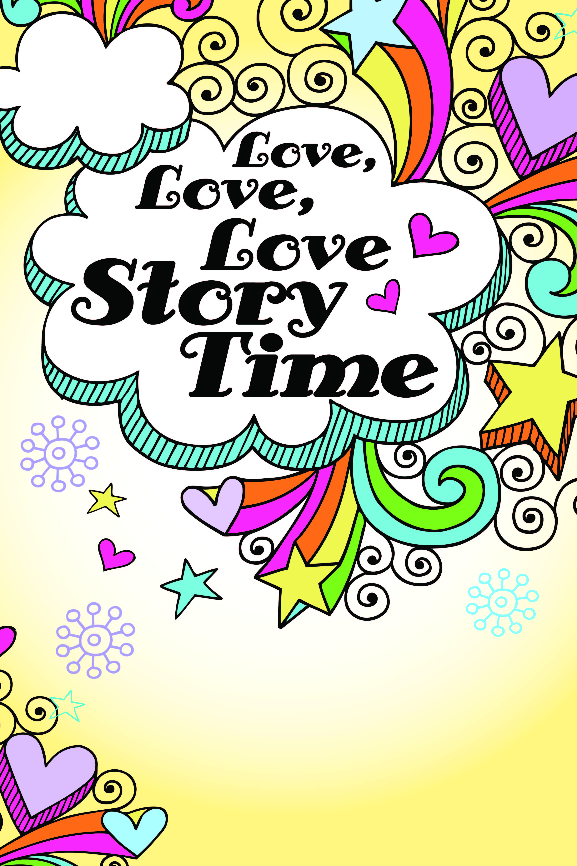
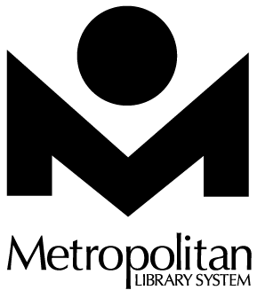
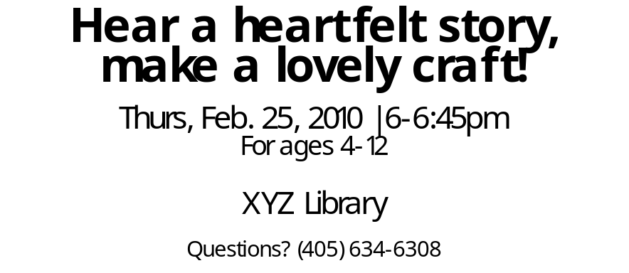
Hear a heartfelt story,
make a lovely craft!

Thurs, Feb. 25, 2010 | 6-6:45pm
For ages 4-12

XYZ Library

Questions? (405) 634-6308
Hear a heartfelt story,
make a lovely craft!

Thurs, Feb. 25, 2010 | 6-6:45pm
For ages 4-12

XYZ Library

Questions? (405) 634-6308

