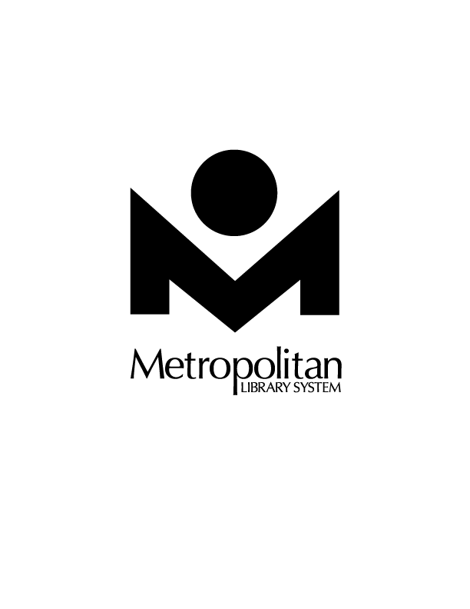

www.metrolibrary.org

Belle Isle Library Presents:

All About Snakes:

Snakes In The Library!

Learn how to be comfortable with reptiles!

Learn about snakes and having one as a pet. Larry Daniel, President of the OKC Herpetological Society, will teach the class, answer your questions, and give you a chance to touch and examine some real-life snakes!

Tuesday, July 10

6:30pm

*Age 5 and up. Sign up at the reference desk. This event is free*

*and co-sponsored by the OKC Herpetological Society.*

**Belle Isle Library | 5501 N. Villa | (405) 843-9601 | www.metrolibrary.org**

Belle Isle Library Presents:

All About Snakes:

Snakes In The Library!

Learn how to be comfortable with reptiles!

Learn about snakes and having one as a pet. Larry Daniel, President of the OKC Herpetological Society, will teach the class, answer your questions, and give you a chance to touch and examine some real-life snakes!

Tuesday, July 10

6:30pm

*Age 5 and up. Sign up at the reference desk. This event is free*

*and co-sponsored by the OKC Herpetological Society.*

**Belle Isle Library | 5501 N. Villa | (405) 843-9601 | www.metrolibrary.org**



www.metrolibrary.org