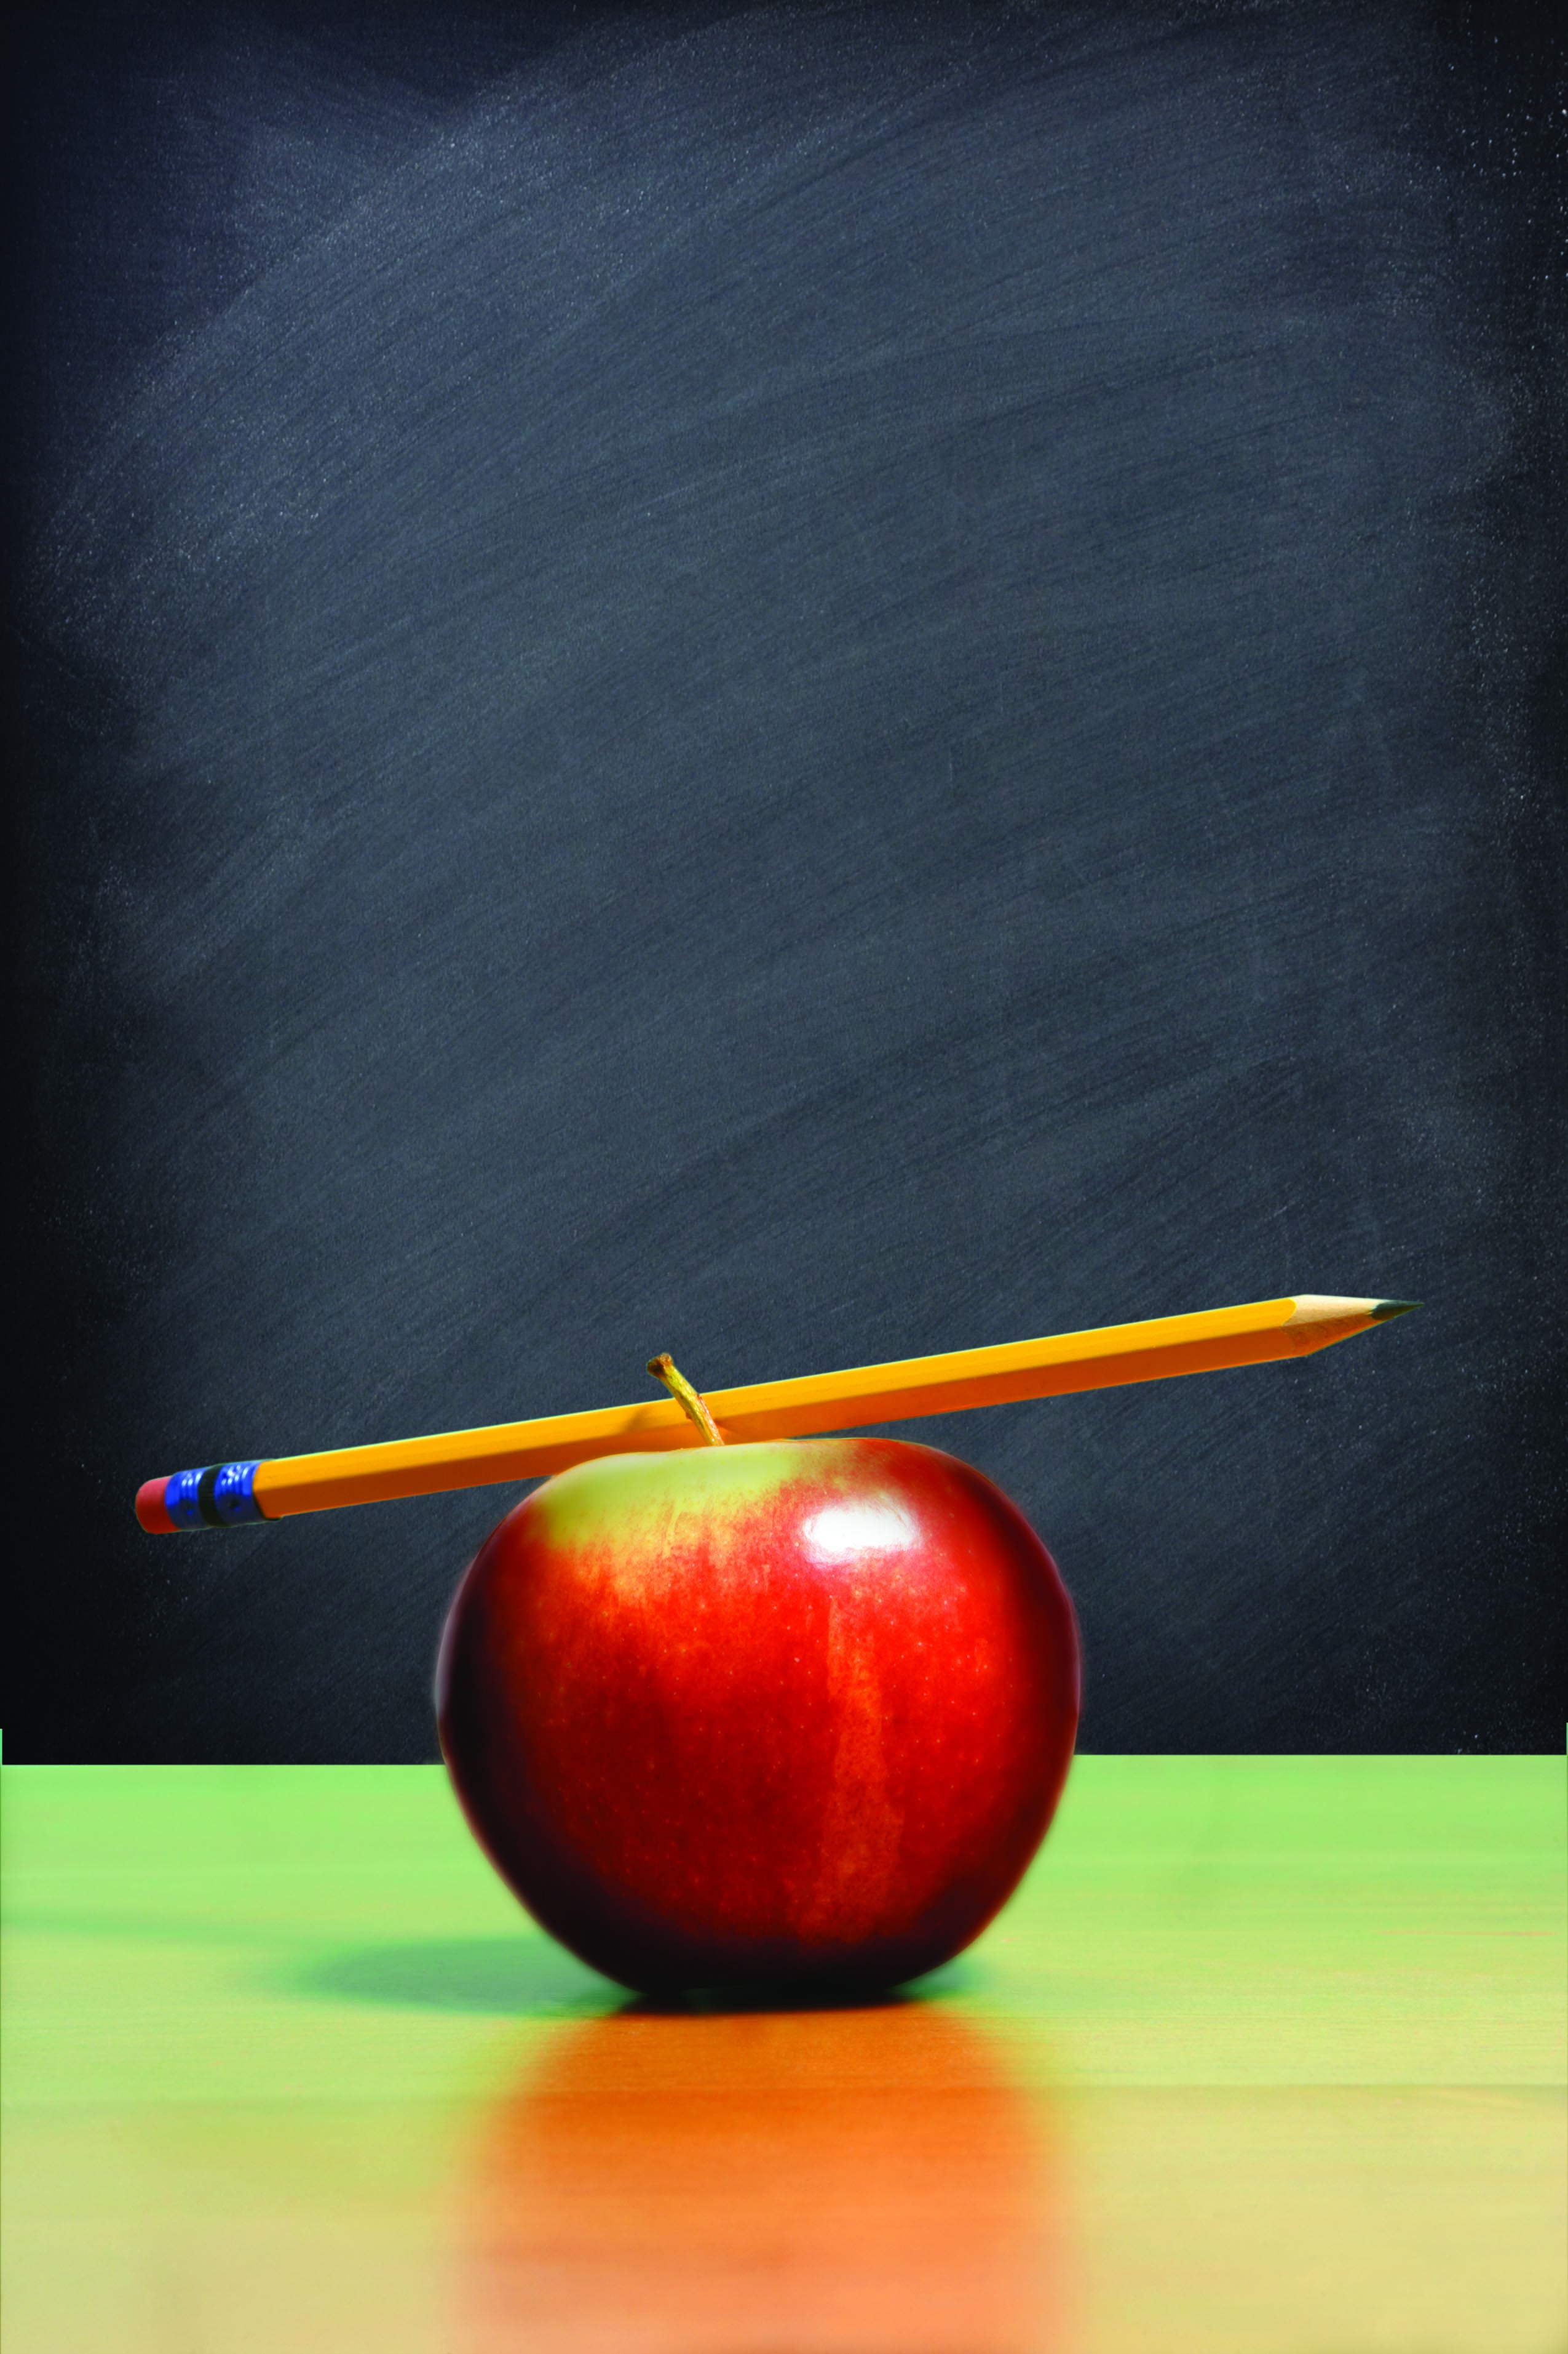

Homework
Help
Homework
Help
High school & college students will be able to answer questions or read
with young people.

Call 555-1212 for more information and
to pre-register.
Grades 1-5

XYZ Library
123 Main

High school & college students will be able to answer questions or read
with young people.

Call 555-1212 for more information and
to pre-register.
Grades 1-5

XYZ Library
123 Main

