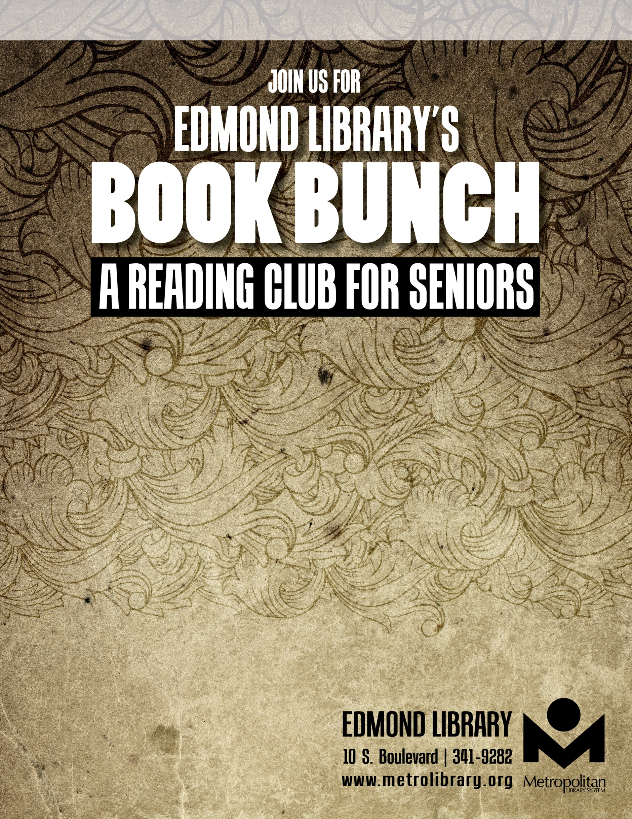
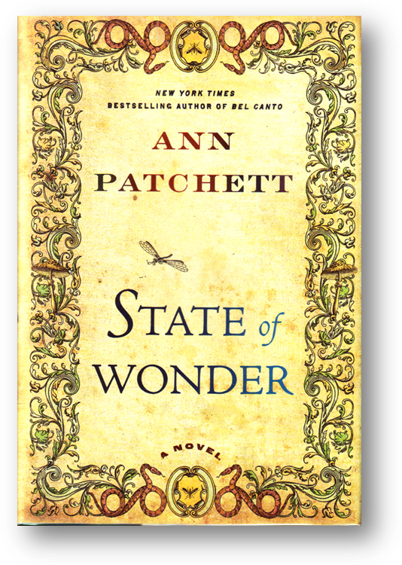
NOVEMBER 10
2:00pm

A provocative novel of morality and miracles, science and sacrifice set in the Amazon rainforest – a gripping adventure story and a profound look at the difficult choices we make in the name of discovery and love.

