**How to Implement Tandems at Your Schools and Library**

Oklahoma City Public Schools + Metropolitan Library System

**We have created a few different pieces of collateral to assist you in helping your students/patrons link their accounts ahead of your winter reading challenges.**

# Notes for all:

1. Accounts can only be linked via the reader view, on the web app. Linking is not available on the administrative dashboard or inside the mobile app. However, once linked, all logging will count on both the school and library sites, regardless of where logging is done (web or mobile app).
2. Logging will count on both student/teacher accounts only from the moment the accounts are linked and going forward. The system does not retroactively add reading sessions that had previously been logged.

# 

# Collateral For Libraries:

*Librarian Guide:* This is a staff-facing guide. It includes directions to link accounts for both new and existing library accounts. *All school accounts are created via our connection with a rostering system, so it is not possible to create a new school account.*

*Library Guide - Existing Account:* This is a patron-facing flyer, to be customized and shared with any current patrons who attend OKCPS who are interested in linking their accounts.

*Library Guide - New Account:* This is a patron-facing flyer, to be customized and shared with any new patrons who attend OKCPS who are interested in linking their accounts.

# Collateral For Schools:

*School Guide:* This guide is a take-home flyer for your students. The instructions have been customized as much as possible to your school specifications, but each school will have the ability to update their microsite and/or SSO instructions, depending on how their students access Beanstack.

*Bookmark:* This is another take-home item for your students. The instructions have been customized as much as possible to your school specifications, but each school will have the ability to update their microsite and/or SSO instructions, depending on how their students access Beanstack.

# 

# For schools - how tandems work from the school side:

1) When your students sign-in, they will see a banner across the top of their homepage, letting them know they have the ability to link their school account with their library account. Note: If a student clicks “Dismiss”, the banner will reappear for them, but they can also access the “Link Account” page using the gear in the upper right corner.

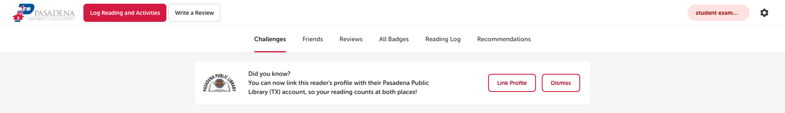

2) When they click "Link Profile", they will be taken to a page to link their accounts. On this page, they will enter their login information for their library Beanstack account. If they do not have a library account, they are given the option here to create one. *Note: Their library account may be part of a larger family account, so be sure to select the correct reader!*

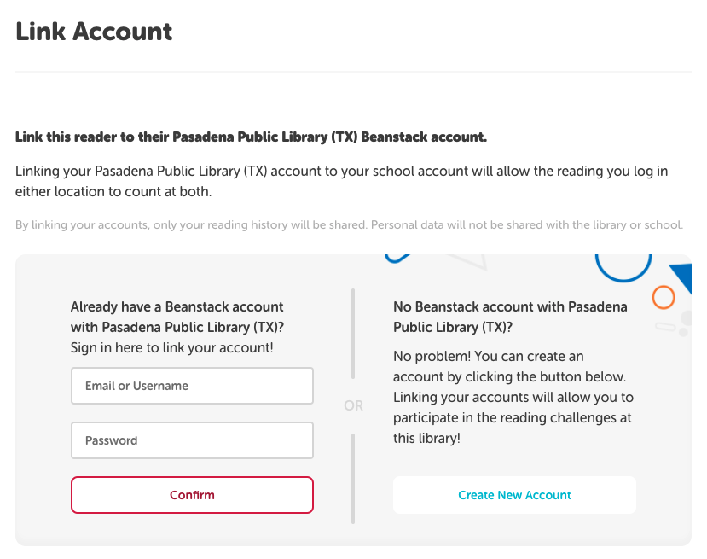

3) Once the student has signed in to their existing account or chosen to create a new one, they'll click "Link Profiles" and receive a confirmation message.

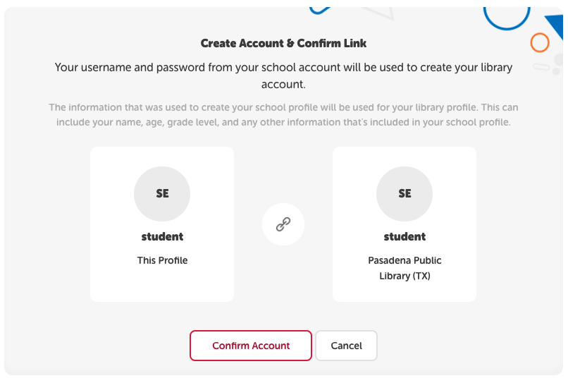

4) The student can revoke the link at any time by clicking on the settings gear in the upper right-hand corner --> Link Profile --> Revoke Link.

5) Once linked, the student will have the ability to toggle between their school and library accounts, and also to see challenges available on each site. However, they should only log their reading in one place, because it will count in both!

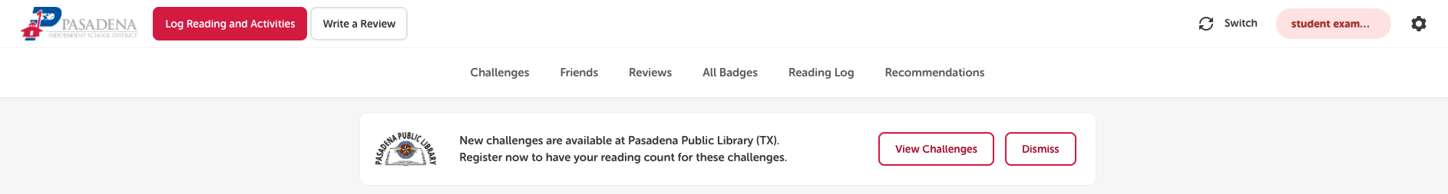

# 

# 

# 

# For Libraries - how tandems work from the library side:

On the library side, there are 2 different scenarios: a new patron registering + linking accounts, or an existing patron linking accounts. Please note: linking accounts can only be done from the patron view on the web app. It cannot be done in the administrative dashboard

*For a new patron:*

1) Guide the reader (student or teacher) to register on your site.

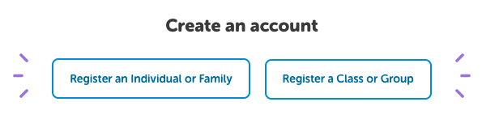

2) Make sure the reader enters their correct school. Upon selecting their school from the dropdown, an additional dialog box will appear, offering to link with their school account.

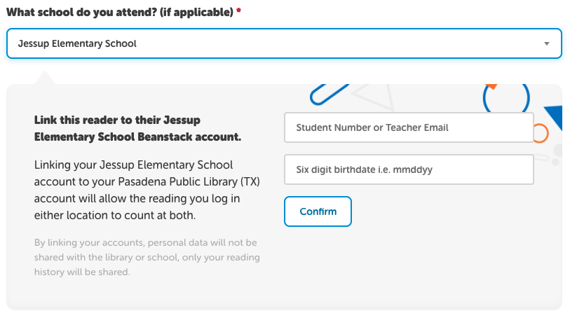

3) The student/teacher will then enter their school Beanstack information. (Note: This login information is what they use for mobile app login, not their Clever credentials.) All OKCPS students login using their student username (firstname.lastname) & birthday (mmddyy) as the password. Teachers login using their school email and beanstackreads as the password. Click “Confirm”. You will receive a confirmation when the accounts are properly linked!

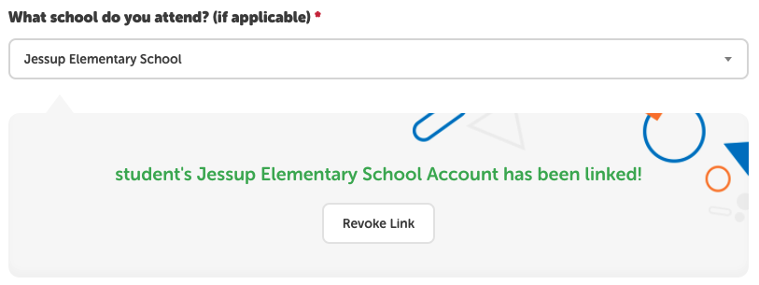

4) Continue with the registration process. Then, the student/teacher will register for all new challenges available at your library and at their school!

*For an existing patron:*

1) Have the patron sign-in to their library account on a computer.

2) Navigate to their settings (Edit Reader).

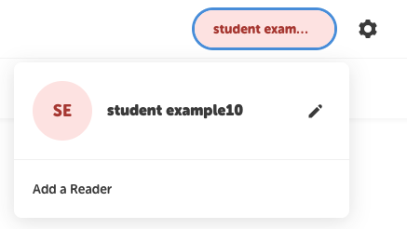

3) Under "Basic Information", when a student/teacher chooses their school, they’ll see a similar dropdown to when creating a new account. Make sure the student/teacher has selected the correct school. They'll then see the option to login using their school Beanstack site credentials. All OKCPS students login using their student username (firstname.lastname) & birthday (mmddyy) as the password. Teachers login using their school email and beanstackreads as the password.

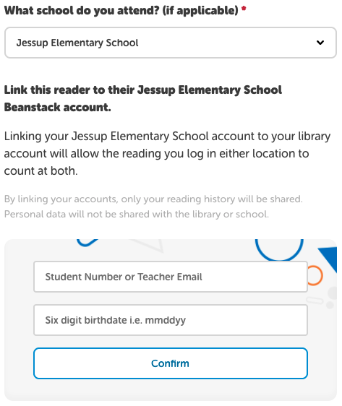

4) Click "Link Profiles". You will receive a confirmation when the accounts are properly linked!

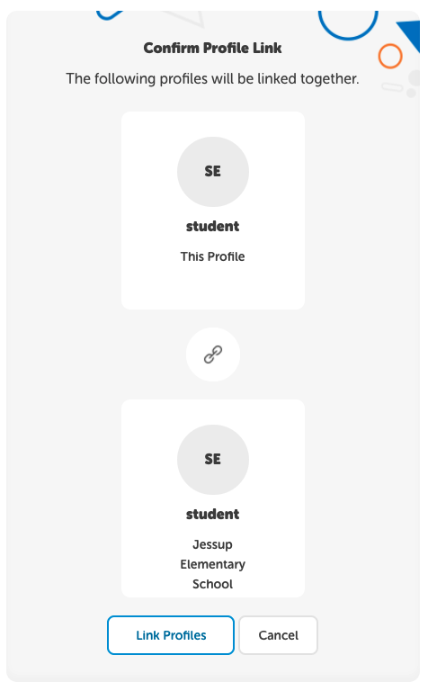

5) Once linked, the student will have the ability to toggle between their school and library accounts, and also to see challenges available on each site. However, they should only log their reading in one place!