Self-Reported Training Quick Guide

This guide will demonstrate how to a Self-reported training (SRT). Self-reported trainings are professional development activities completed outside of MetroU that a learner would like to include on their MetroU transcript.

- When you submit a self-reported training, you will receive an email from MetroU the submission is pending your Manager’s approval.
  - The email will include: your name, the title of the training you attended, and the date you attended.

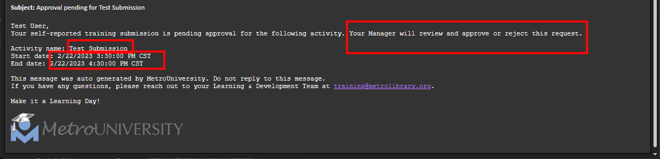
See example email below for reference:

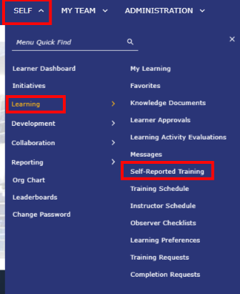
- To submit a self-reported training log in to MetroU, then navigate to SELF < Learning < Self-Reported Training.

- Select New in the Self-Reported Training window.
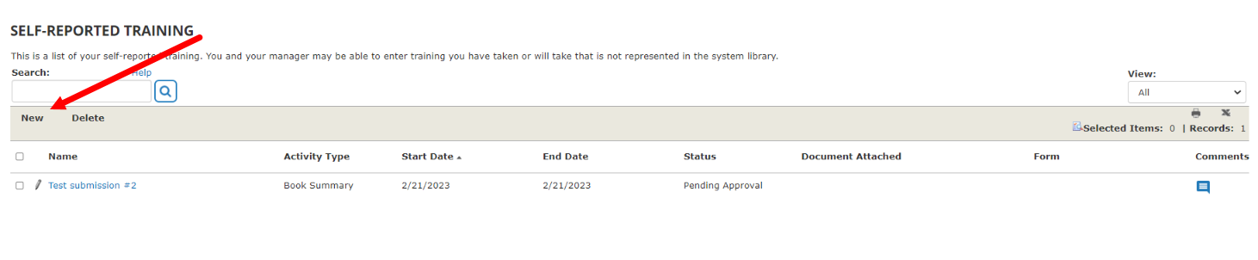

- The Self-Reported Training Properties page will appear. This is where you can enter the details of your outside professional development training.

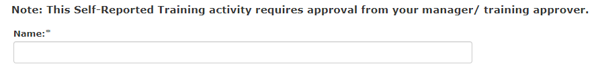
- Name: Include the name of the training you attended.
- Upload Attachment/Certificate: Upload the certificate of completion, if provided. We understand not all training will provide this so this step is optional. We highly encourage you to attach if you have a certificate of completion as you can look back on, print, and review this document from MetroU at a later date.
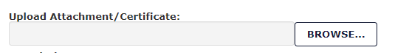

- Description: Add the description of the training you attended. This step is also optional.
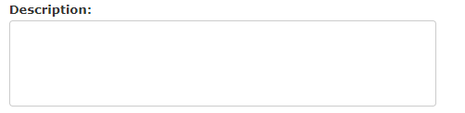
- Activity type: Add the Activity type in the drop-down field. The Activity type is how you would classify the type of training you attended. There are many options to choose from in this field, including course, webinar, conference, and book summary. If you are not sure which activity type to choose use your best judgment.
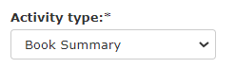
- Content type: We also encourage you to tie the training to one of our MLS core values under the Content type drop down menu.
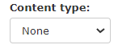
- Start date and End date: Specify the start and end date and time of the training you attended. You can also include the duration or length of the training in the duration field.

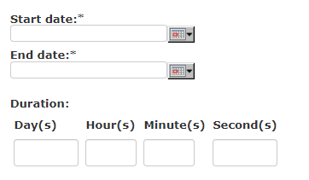
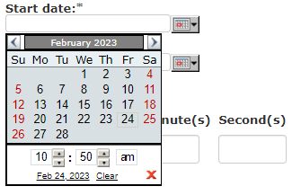

  - To add the start date and end date click the grey calendar icon, then add the date and time. Click the red ‘X’ to close the calendar window.

- Name of presenter: This is an optional field where you can specify the specific speaker/presenter or the organization the training was provided by.
- Learner Comments: In this field share two takeaways and how you will take this training back to your role.
IMPORTANT: Your supervisor will review the comments made in this section when reviewing your submission. It is important to include this information as they do have the ability to reject a self-reported training submission.

- That’s it! Click at the bottom of the page. You can view your submission, along with any future submissions on the Self-Reported Training window.
- You have submitted a self-reported training request. It will display on your MetroU transcript after it is approved. You will also receive a second email indicating it was approved or rejected, along with any additional comments made by your Manager.

Additional Resources:
Library – How To
  - MetroU How to Submit a Self-Reported Training

